cocKtail menu WST$30.00  cosmopolitan  Vodka, Cointreau, Cranberry Juice and Fresh Lime  City classic served in paradise!  japanese slipper  Midori, Cointreau & Fresh Lime Juice  Smooth and Relaxing  BLUE MOANA  Blue Curacao Liqueur, Creme de Coconut, White Rum mixed with pineapple juice. Perfect holiday cocktail  MARGARITA  Tequila, Cointreau and Fresh Lime Juice  Served Shaken or Frozen  mojito  White Rum, Soda Water, Fresh Lime Juice and Mint  Absolutely Refreshing!  pina colada  White Rum, Malibu, Coconut Cream and Pineapple Juice  Classis Island Cocktail  PAPAYA daiquiri  White Rum, Vodka, Fresh Lime & local Papaya  Fresh & Fruity  PIRATE PUNCH  Dark Rum, White Rum, Spiced Rum with Orange & Pineapple Juice, Fresh Lime and Grenadine Splash!  nutty monkey  Frangelico, Kahlua, Coconut Cream and Fresh Banana  Our Signature Island Cocktail  HIBISCUS LOVE  Vodka, Triple Sec, Lime, Pineapple Juice and Hibiscus Oil  Made with our own Hibiscus flowers!  MAI TAI  Classic Blend of Island Rums and Fresh Juice  YE | 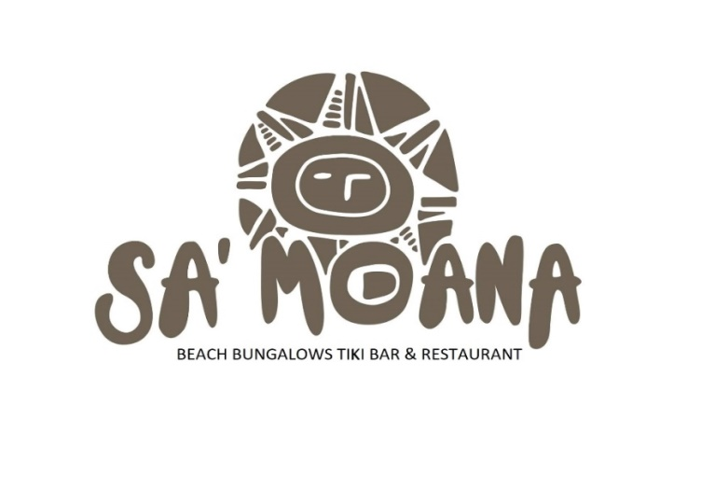  PLEASE ORDER ALL FOOD & DRINKS AT THE BAR. OUR FRIENDLY LOCAL STAFF WILL BRING YOUR MEALS TO THE TABLE.  HAPPY DINING!  DAY GUESTS ARE WELCOME.  A $25 WST MINIMUM SPEND PER PERSON IS APPLICABLE.

Appetizers  tuna cerviche (oka) WST$30  Fresh local raw tuna marinated in fresh lime juice and local coconut cream served with diced tomatoes and cucumber. Served with a toasted garlic bread slice.  sa’moana poke WST$30  Fresh local raw tuna seasoned with garlic, sesame oil, soy sauce and fresh chili served with fresh coconut slices – local favorite. Served with a garlic bread slice.  TUNA SASHIMI WST$30  Fresh local raw tuna sliced thin and layered on shredded white and red cabbage served with a soy sauce and wasabi mix and fresh lime garnish.  esi soup (v) wst$30  Fresh Papaya soup garnished with local coconut cream and white pepper. Served with a toasted garlic bread slice.  pumpkin & taro soup (v) wst$30  Fresh organic pumpkin soup garnished with local coconut cream, fresh chili and crispy taro flakes. Served with a toasted garlic bread slice. | italian bruschetta (v) WST$25  Fresh tomato, cucumber, onion and basil marinated in olive oil, fresh chili and garlic served on toasted crusty bread.  south seas bruschetta wst$30  Fresh local raw tuna diced into small cubes with tomato, cucumber and onion marinated in olive oil, fresh chili and garlic served on toasted crusty bread. A must try!  quesadillas (v) WST$30  Tiki Classic! Mexican Quesadilla filled with local vegetables sautéed in special Mexican spices with your choice of filling:  Fish, Beef or Veggie  CHILI BEEF SALAD WST $40  Local beef strips seared in chili flakes & garlic. Served on a fresh salad and topped with shaved green papaya & our light dressing & a toasted garlic bread slice.  CATCH OF THE DAY SALAD wst $40  Seared steak of local catch drizzled with lime and a hint of local turmeric sautéd & served on a bed of seasonal salad with our light salad dressing & toasted garlic bread.

sub,sandwich & wraps  blt sandwich WST$35  Toasted Classic Bacon, Lettuce & Tomato (Chunky Triple Decker). Served with Fries of your choice on brown or white bread.  mIxed salad (V) WST$30  Sandwich or wrap. Filled with fresh local salad, tomatoes, cucumber, carrot, onion and lettuce. Served with side of Fries of your choice.  Seared Tuna WST$35  Sandwich or wrap. Fresh tuna seared in light lime and ginger dressing with fresh local salad mix. Served with side of Fries of your choice.  PLEASE CHOOSE EITHER WHITE OR BROWN BREAD, TOASTED OR FRESH.  MAIN MEALS  BBQ BEEF SKEWERS wst$45  4 rump steak skewers, onion, tomato and peppers, flamed in our bbq & garlic sauce. Served on a bed of spicy rice with a slice of toasted garlic bread.  ISLAND FISH tacos wst$45  Local fresh Wahoo pan fried in Tiki Cajun Spices, served in 4 crispy taco shells, topped with melted cheese and Tiki mayo.  WET Burritos wst$45  Beef, fish or Veggies pan fried in our cajun sauce served in 2 soft tortillas grilled and topped with tex-mex sauce and melted cheese. Served with spicy rice. | TOASTED veggie WRAP (V) WST$30  Hot toasted wrap filled with fresh local roasted vegetables seared in light coconut and lime jus. Served with Fries of your choice.  TROPICAL sub wst$35  Foot long pizza sub topped with fresh local ham, fresh papaya topped with Napolitana sauce and melted cheese.  Served with side of Fries of your choice.  napolitana sub (v) WST$35  Foot long pizza sub topped with our special, fresh Napolitana sauce, melted cheese and herbs.  Served with side of Fries of your choice.  crumbed wahoo wst$45  Fresh wahoo crumbed with coconut batter and pan fried with fresh chili, garlic, onion and coconut cream on a bed of steamed rice. Served with buttered bok choy and long beans.  fisH n chips wst$45  Coconut & Herb battered Wahoo served with fries of your choice, fresh local lime wedges, homemade tartare sauce and onion rings.  TUNA COCONUT BAKE wst$45  Fresh tuna sautéed in local coconut cream, onion and fresh basil. Baked in half a coconut shell, served with steamed rice or basket of fries of your choice and a slice of toasted garlic bread

sa’moana curry (v) WST$45  Red or green curry with fresh chili served with a side steamed coconut rice and local fruit garnish.  Fish, Beef or Vegetarian – let the waiter know how hot you like it!  PENNE PUTANESE WST$40  Mediterranean penne pasta with tomato, fresh garlic, onion, basil & olives. Topped with seared Catch of the Day & served with a slice of garlic bread.  Fish or Vegetarian.  vegGIE skEWERS (v) wst$38  4 skewers of tender chunky, local veggies sautéed and flamed in our special sate’ sauce. Served on a bed of steamed rice and a slice of toasted garlic bread  GOURMET BURGERS  ALL BURGERS SERVED WITH A CHOICE OF EITHER POTATO, BANANA OR TARO FRIES.  SA’mOANA burger WST$40  100% local beef patty (250g), fresh and seasoned with our spices served on a lightly toasted bun with fresh salad, tomato, cucumber, onion and cheese.  FISH BURGER WST$40  Succulent local Wahoo or Snapper steak (250g) seasoned with local herbs and spices served on a lightly toasted bun with tartare sauce and salad.  VINTAGE CLASSIC WST $40  100% local beef patty (250g) seasoned to our secret recipe served on a lightly toasted bun with dill pickle, mustard & cheese.  sides  garlic bread wst$10  steamed rice wst$10  green salad wst$10  banana fries wst$10  salsa wst$3  sauces wst$3 | CHICKEN SKEWERS WST$45  4 tender bbq chicken honey soy skewers with onion and peppers, served on bed of spicy rice with a slice of toasted garlic bread.  vegGIE stackS (v) wst$38  Pan fried fresh local vegetables stacked with tomato concasse topped with melted cheese. Served with steamed rice.  BUCKET OF FRIES wst$10  As an extra or for a lunch time snack fried local taro, fried green banana (our favourite!) or imported potato fries served in a bucket. Salt, pepper, vinegar & ketchup available on the table.  veggie burger (v) WST$40  100% local vegetable patty (220g), freshly cooked and seasoned with local herbs served on a lightly toasted bun with fresh salad, tomato, cucumber, onion and cheese.  Tiki TROPICAL WST$40  100% local beef patty (250g) seasoned to our special recipe served on a lightly toasted bun with tropical sweet chili mayonnaise and local fruit salsa (esi or pineapple).  NEW YORK BURGER wst$40  100% local beef patty (250g) seasoned to our secret recipe served on a lightly toasted bun with 2 Slices of bacon, pickles, fried onion, bbq sauce and cheese

kids menu  kids beef burger WST$25  Local beef seasoned patty served on a lightly toasted bun with fresh salad, tomato, cucumber, onion and cheese. Served with side of fries of your choice.  penne napolitana WST$25  Penne pasta topped with Napolitana (tomato) sauce and cheese served with garlic bread.  blt sandwich WST$25  Classic Bacon, Lettuce & Tomato sandwich, plain or toasted. White or brown bread. Served with fries of your choice.  CHICKEN SKEWERS WST$25  2 tender bbq chicken honey soy skewers with onion and peppers, served on bed of steamed rice.  desert menu WST$30  please see our daily specials BOARD | kids tropical sub WST$25  Half foot long pizza sub topped with fresh local bacon, fresh pineapple with Napolitana sauce and melted cheese. Served with side of fries of your choice,  kids fish n chips wst$25  Fresh local catch of the day battered and served with fries of your choice, fresh lime wedges, our homemade tartare sauce and onion rings.  BBQ BEEF SKEWERS wst$25  2 skewers of chunky beef, onions & tomato sautéed and flamed in bbq and garlic sauce. Served with side of steamed rice and salad.  CHICKEN NUGGETS WST$25  8 tender chicken nuggets served with potato fries

